**Assignment 4:**

a. Create a simple Mobile Website using jQuery Mobile.

b. Deploy/Host Your web application on AWS VPC or AWS Elastic Beanstalk. Mini Project

Theory:

**Part a:**

**jQuery Mobile**

JQuery Mobile is a user interface framework, built on jQuery Core and used for developing responsive websites or applications that are accessible on mobile, tablet, and desktop devices. It uses features of both jQuery and jQueryUI to provide API features for mobile web applications. This tutorial will teach you the basics of jQuery Mobile framework. We will also discuss some detailed concepts related to jQuery Mobile.

Why Use jQuery Mobile?

* It creates web applications that will work the same way on the mobile, tablet, and desktop devices.
* It is compatible with other frameworks such as PhoneGap, Whitelight, etc.
* It provides a set of touch-friendly form inputs and UI widgets.

Features of jQuery Mobile

* It is built on jQuery Core and "write less, do more" UI framework.
* It is an open source framework, and cross-platform as well as cross-browser compatible.
* It is written in JavaScript and uses features of both jQuery and jQuery UI for building mobile-friendly sites.

Download jQuery Mobile

When you open the link https://jquerymobile.com/, you will see there are two options to download jQuery mobile library.

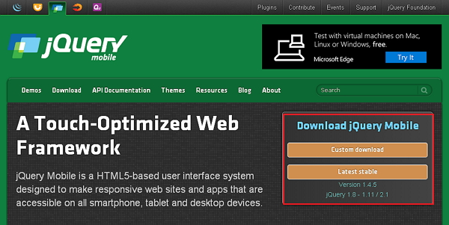

Click the *Stable* button, which leads directly to a ZIP file containing the CSS and JQuery files, for the latest version of jQuery mobile library. Extract the ZIP file contents to a jQuery mobile directory.

This version contains all files including all dependencies, a large collection of demos, and even the library's unit test suite. This version is helpful to getting started.

**Part b:**

**What is Cloud Computing?**

Cloud computing is a term referred to storing and accessing data over the internet. It doesn’t store any data on the hard disk of your personal computer. In cloud computing, you can access data from a remote server.

**What is AWS?**

The full form of AWS is Amazon Web Services. It is a platform that offers flexible, reliable, scalable, easy-to-use and, cost-effective cloud computing solutions.

AWS is a comprehensive, easy to use computing platform offered Amazon. The platform is developed with a combination of infrastructure as a service (IaaS), platform as a service (PaaS) and packaged software as a service (SaaS) offerings.

 It is a secure cloud services platform, offering compute power, database storage, content delivery and other functionality to help businesses scale and grow.

In simple words AWS allows you to do the following things- Running web and application servers in the cloud to host dynamic websites.

**History of AWS**

* 2002- AWS services launched
* 2006- Launched its cloud products
* 2012- Holds first customer event
* 2015- Reveals revenues achieved of $4.6 billion
* 2016- Surpassed $10 billon revenue target
* 2016- Release snowball and snowmobile
* 2019- Offers nearly 100 cloud services
* 2021- AWS comprises over 200 products and services

**Important AWS Services**

Amazon Web Services offers a wide range of different business purpose global cloud-based products. The products include storage, databases, analytics, networking, mobile, development tools, enterprise applications, with a pay-as-you-go pricing model.

**Applications of AWS services**

Amazon Web services are widely used for various computing purposes like:

* Web site hosting
* Application hosting/SaaS hosting
* Media Sharing (Image/ Video)
* Mobile and Social Applications
* Content delivery and Media Distribution
* Storage, backup, and disaster recovery
* Development and test environments
* Academic Computing
* Search Engines
* Social Networking

**Creating an AWS Account** is the first step you need to take in order to learn **Amazon Web Services**.

**Steps to follow are as follows :**

Step 1 – Visiting the Signup Page

Go to https://aws.amazon.com

You should see something like below:

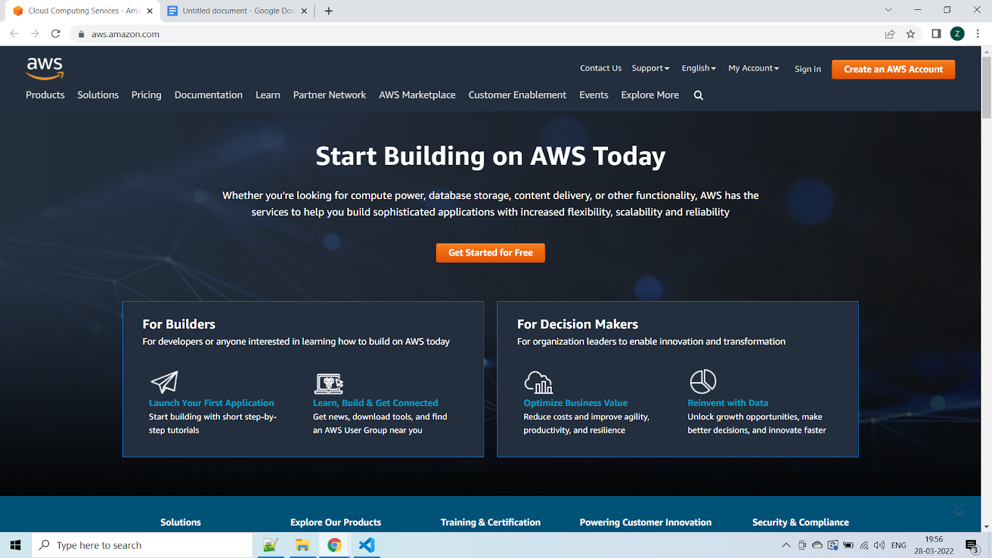

In order to continue, click the **Complete Sign Up** button in the middle of the screen or on the top right corner of the screen. You will see the below screen.

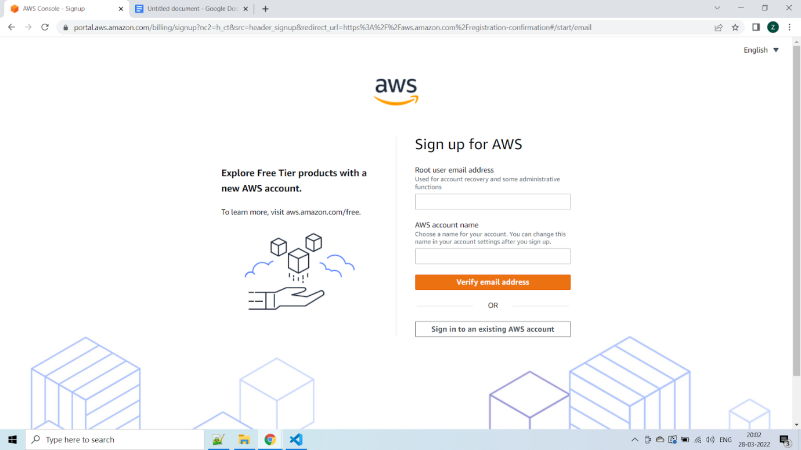

Step 2 – Entering User Details

After you have chosen to **Create a new AWS account**, you will see the below screen asking for few details.

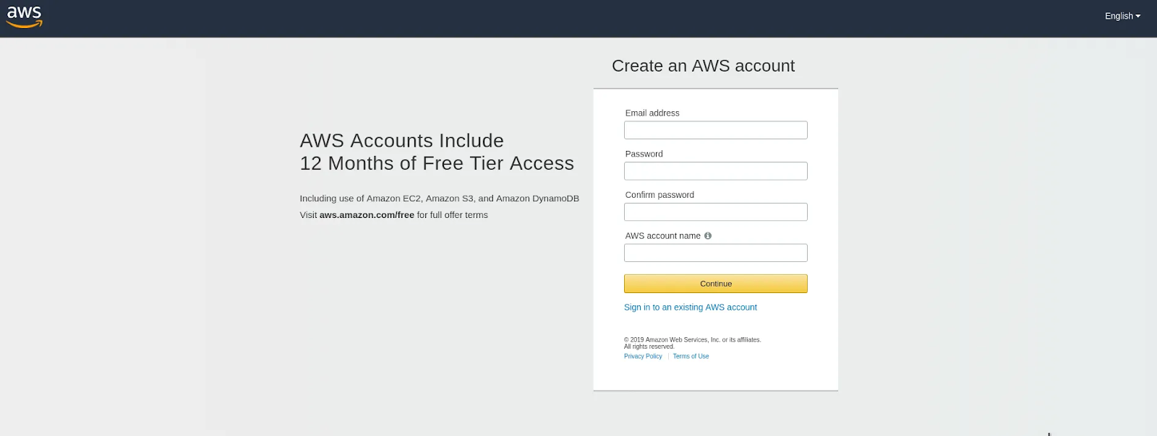

You can fill up the details as per your requirements and click **Continue**.

Next you will be asked to fill up your contact details such contact number, country, address and so on. You should fill them up properly because your contact number is important for further steps.

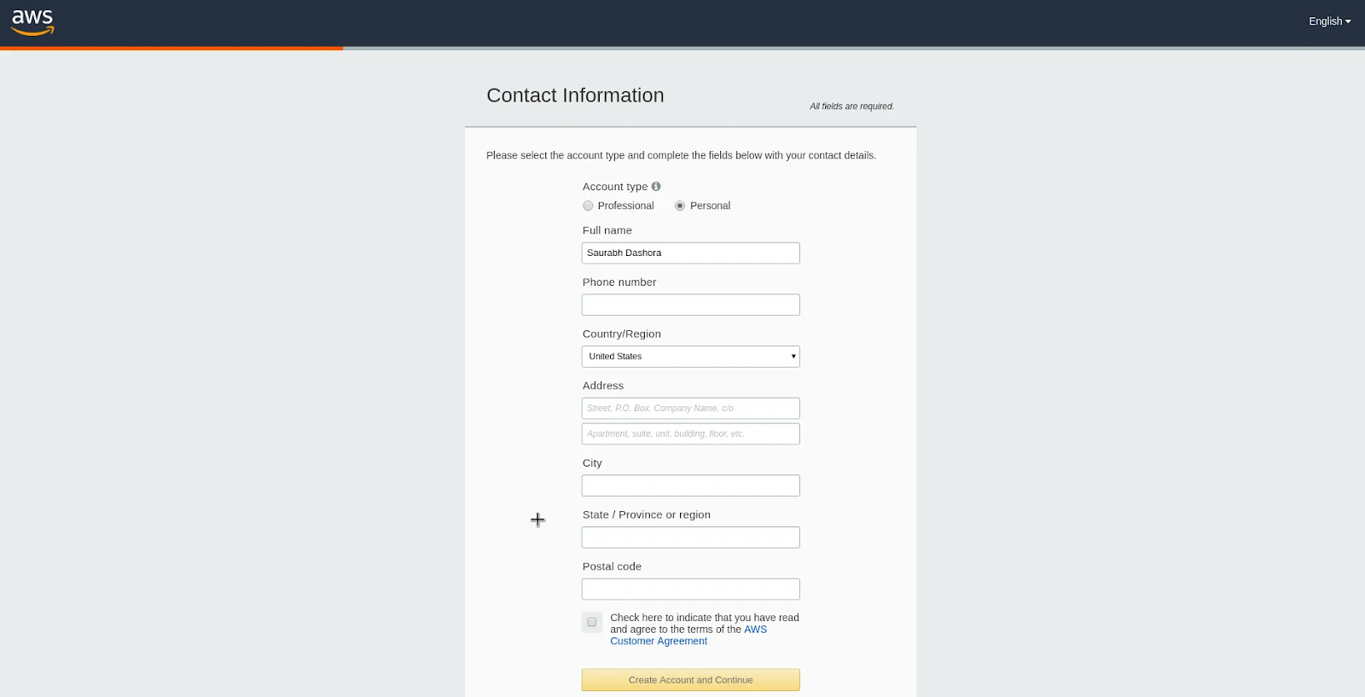

After filling up the details, click on the **Create Account and Continue** button at the bottom of the form.

Step 3 – Filling up the Credit Card details

For **Creating an AWS Account**, you need to enter your **Credit Card** details.

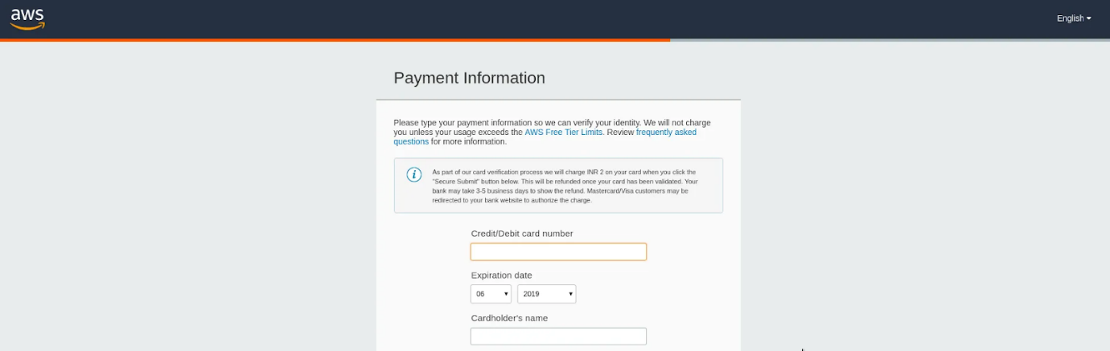

After entering the details, click on **Secure Submit** button. It might take a while to process the request depending on your bank/credit card company servers.

Step 4 – Identity Confirmation

Once the credit card details are confirmed, you will need to complete the **Identity Confirmation** step. You will see the below screen:

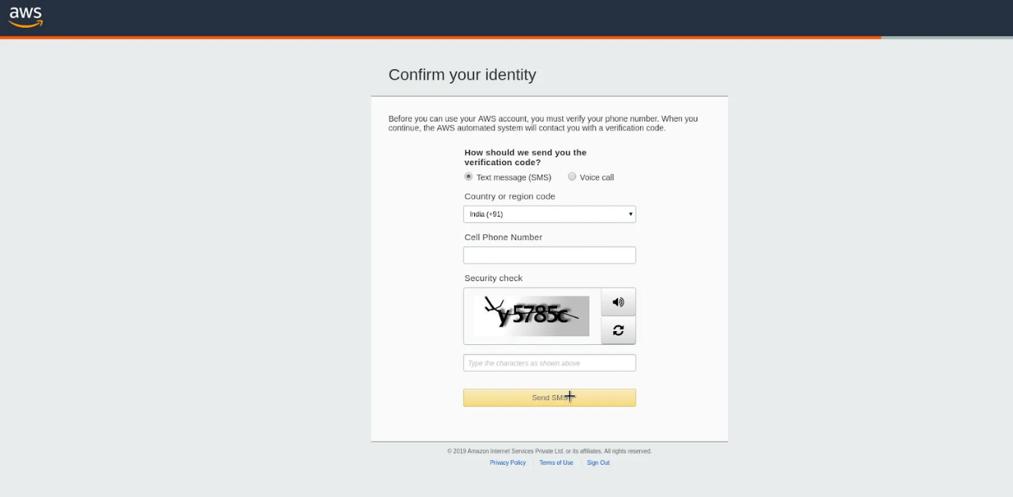

Once you have verified successfully, you should see a screen like below:

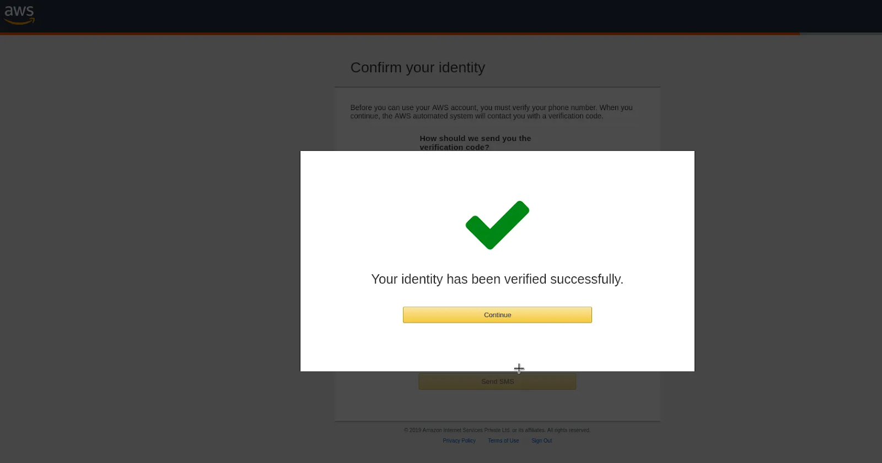

Step 5 – Selecting a Support Plan

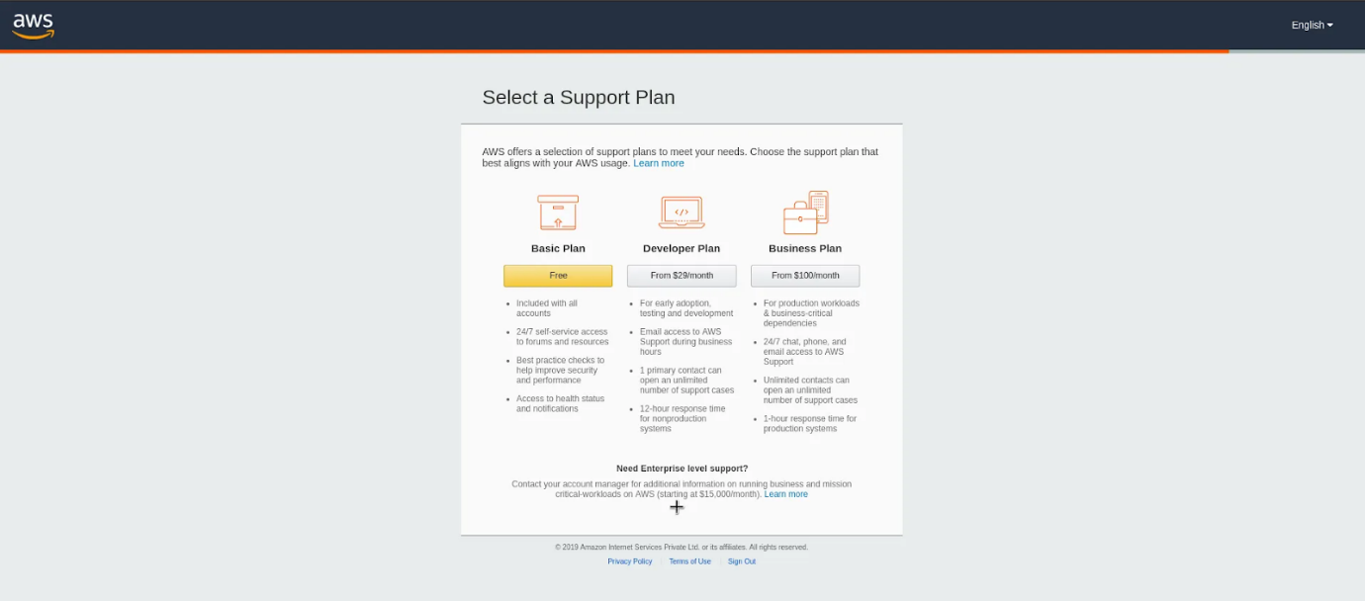

Go for **Basic Plan**. It is Free of cost and great for learning purposes.

The other plans are **Developer Plan** and a **Business Plan**. But both of them are paid options.

Once you select your plan, you will see the below **Welcome** screen. From here on, you can Sign in to your **AWS Console**.

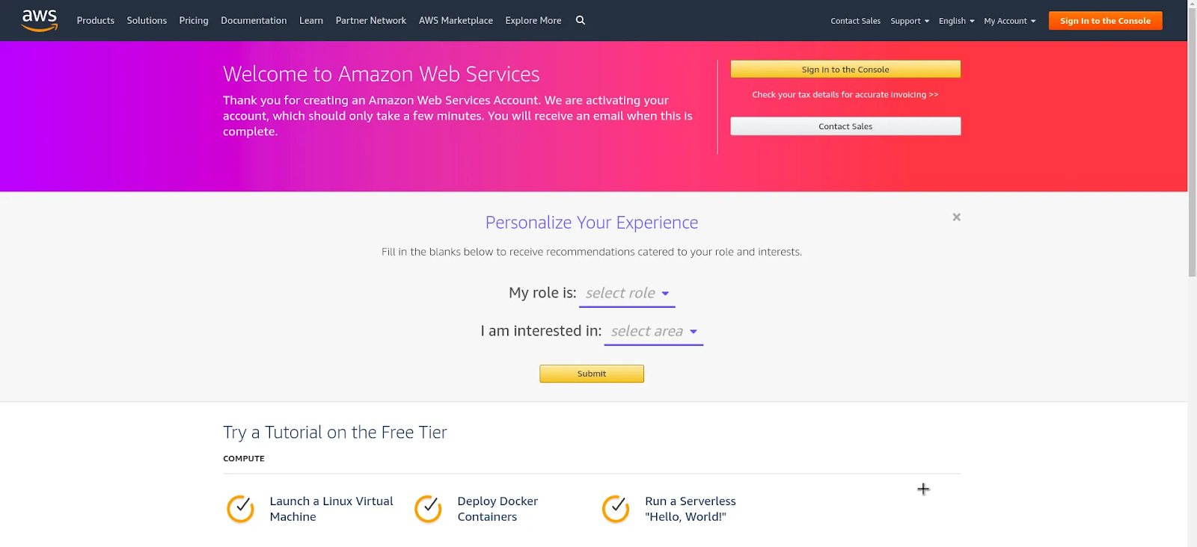

Finally, after logging in, you should be able to see the **AWS Management Console** as below:

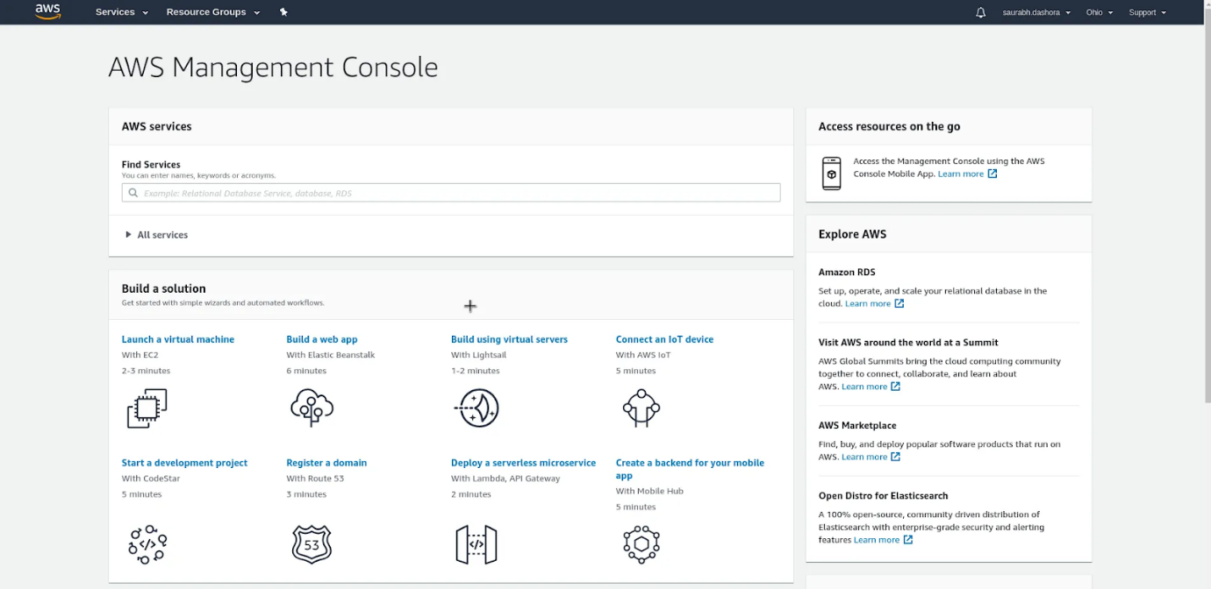

If you have reached this far, you have successfully finished **Creating an AWS Account**.

**Deployment Steps:**

Step 1: Launch a Windows Server Amazon EC2 instance.

Step 2: Configure your source content to deploy to the Windows Server Amazon EC2 instance.

Step 3: Upload your "hello, world!" ...

Step 4: Deploy your Hello World application.

Step 5: Update and redeploy your "hello, world!" ...

Step 6: Clean up your "hello, world!"